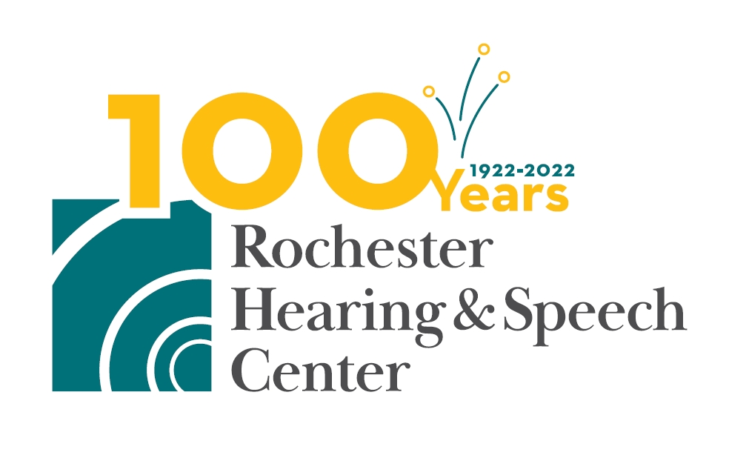

Rochester Hearing & Speech Center Partners with Monroe County Department of Public Health to Offer Free Mobile Hearing Screenings

WHO: Rochester Hearing & Speech Center, in partnership with the Monroe County Department of Public Health, with support from Excellus BlueCross BlueShield.

WHAT: Basic hearing screenings for individuals 18 and over, a pilot program that is part of RHSC’s hearing health campaign, will be provided on a first-come, first-served basis. Screenings are free of charge and open to the public.

WHY: Get tested and consult with an audiologist on site to have your questions answered about general hearing health, hearing aid technology, and hearing protection for loud noise environments. An audiologist will determine if more comprehensive treatment is needed. The goal is to boost awareness of hearing health and to help underserved populations in the local community.

WHEN: Saturday, December 3, 2022
St. Joseph’s Neighborhood Center
417 South Avenue
Rochester, NY 14620
(Note: Masks are required as this is a health facility)

Saturday, December 10, 2022
Arnett Branch Library
310 Arnett Boulevard
Rochester, NY 14619
(Note: Masks are optional)

10:00 a.m. − 2:00 p.m. at both locations

###

Media Contact
Charla Kucko, APR
McDougall Communications
charla@mcdougallpr.com or 585.434.2146 office, 585.750.1706 mobile

